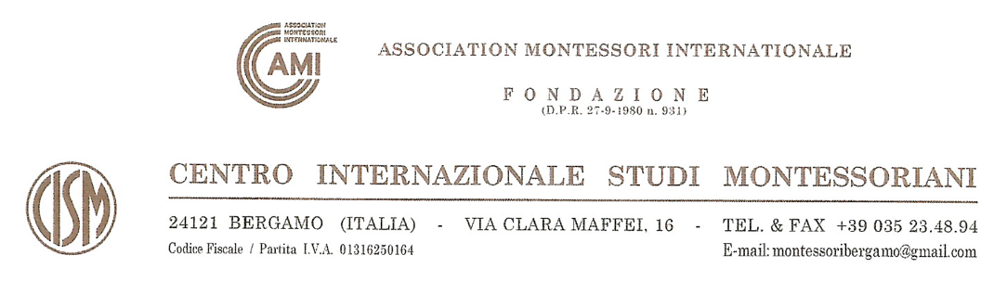

**APPLICATION FORM**

**AMI Orientation Course for Ages 6-12**

|  |
| --- |
| Name and surname:  (family name in block letters) |
| Nationality (also second nationality, if relevant): |
| Address: |
| Phone number: |
| Email: |
| Profession / Employment: |
| AMI membership number (if any): |

**I certify that all the information and answers herein are complete and I agree with personal data processing.**

|  |  |  |
| --- | --- | --- |
| Date  _____________________________ |  | Signature  ___________________________ |

**Documents required for enrolment:**

1. **Application form duly filled in and signed**
2. **Copy of your ID or passport**
3. **Italians only: please include your tax code / codice fiscale.**

**Please send the above documents in an electronic format to** [**montessoribergamo@gmail.com**](mailto:montessoribergamo@gmail.com)**.**

**You will receive the confirmation of enrolment shortly.**